Important Points

1. **Scalability**:
   1. When we talk about Scalability in Kafka, it is in terms of how much parallelly we can read and write from a Kafka Cluster.
   2. So, the more brokers we add, then the more parallelly, we can read/write from/to Kafka Cluster.
   3. Scaling out here means to increase reading and writing from/to Kafka Cluster parallelly.
   4. Scaling is possible due to partition of a topic.
2. Two consumers cannot read from the same partition to avoid double reading.

So Maximum number of consumers are limited by the number of partitions.  
**Example**: If we have 10 partitions, then only maximum 10 consumers are allowed.  
 Yes, if we have 5 consumers, then each consumer will consume from two partitions.

1. One broker may have multiple partitions.
2. Reasons to create partitions from a Topic.
   1. A broker server doesn’t have enough space to store all msgs inside a topic.
   2. A file can’t contain huge amount of data.

1. What is Apache Kafka

1. 
2.   
   **It has following two meanings**:   
   Realtime Stream of Data Pipeline.
3. **Real-time Example**: Smart Meters generating data related data every minute and sending to **Kafka Server**.  
   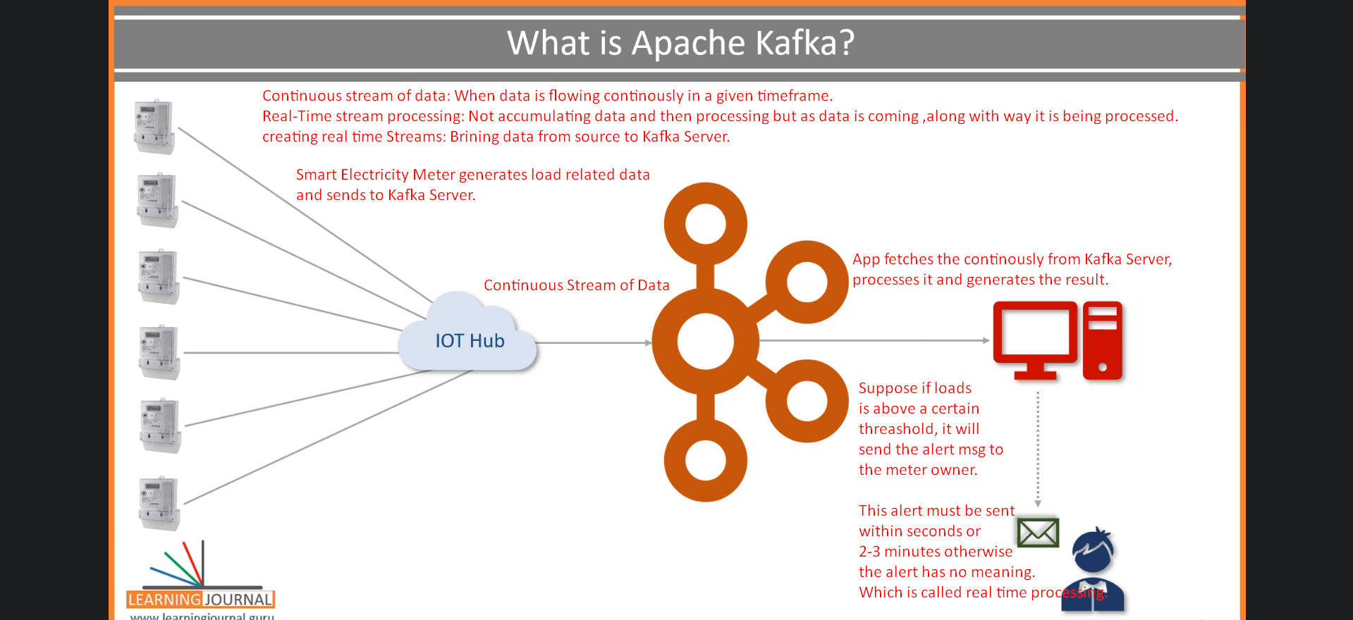
4. 
5. 
6. Apache Kafka adopted **Pub-Sub Messaging System Architecture** and works as an **Enterprise Messaging System**.
7. **Three components of a messaging system** 🡺 Producer(Publisher), Broker, & Consumer (Subscriber).

1. 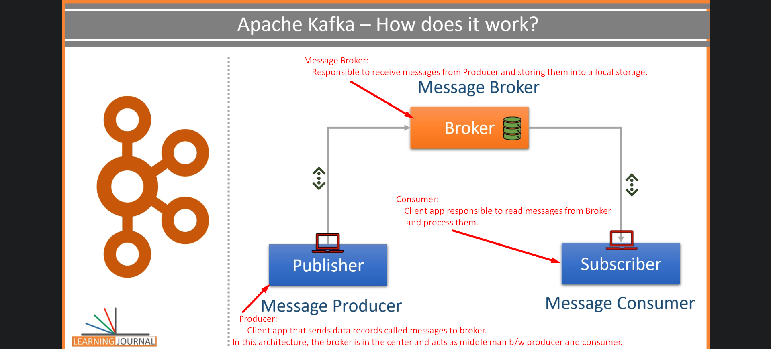  
   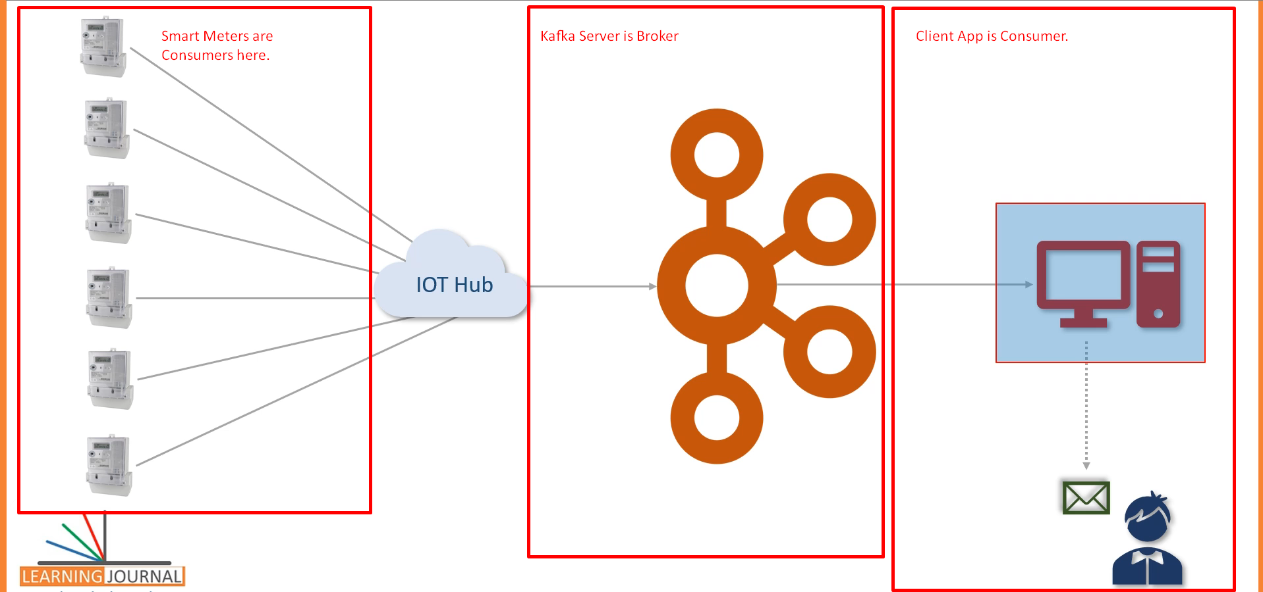

Kafka works as **Pub-Sub Messaging System** where we create a **Producer App** to create and send data **as a stream**.   
We install and configure **Kafka Server** to act as **a message Broker**.  
Finally, we create **consumer app** to process the **data stream** in **realtime**.

1. 
2. Kafka was initially conceptualized and developed at **Linkedin** and later on **open sourced** in 2011 to solve Data Integration
3. 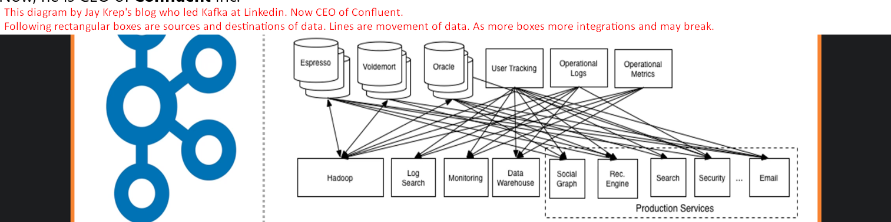
4. 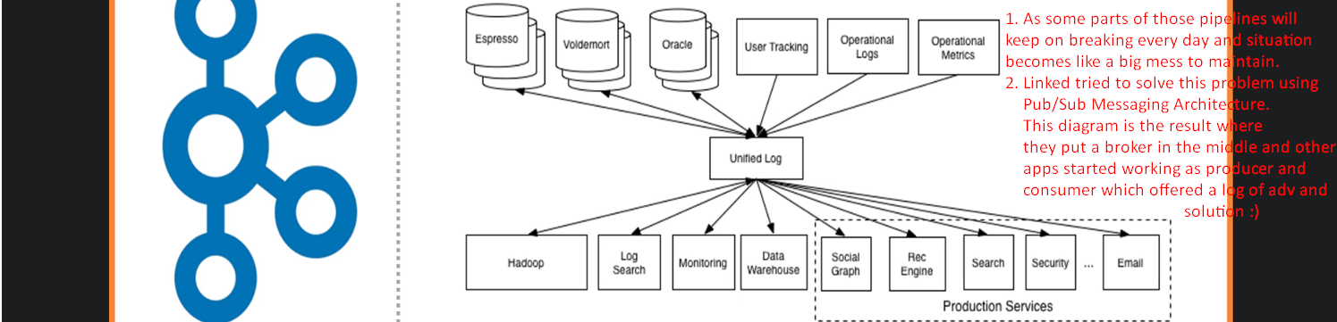
5. 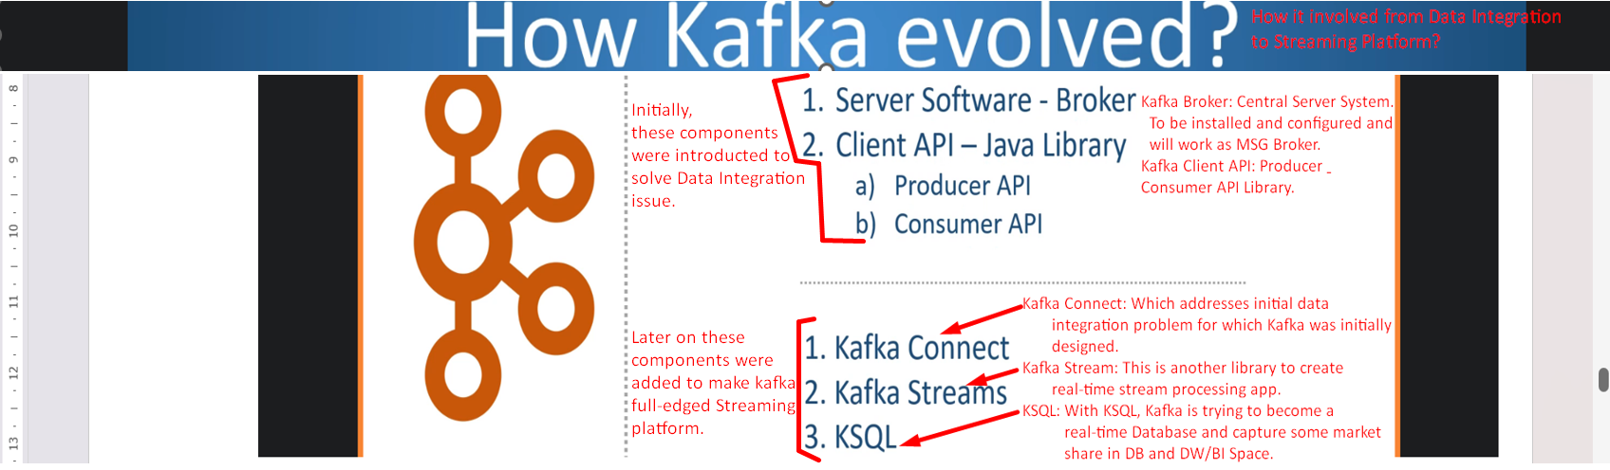
6. 
7. 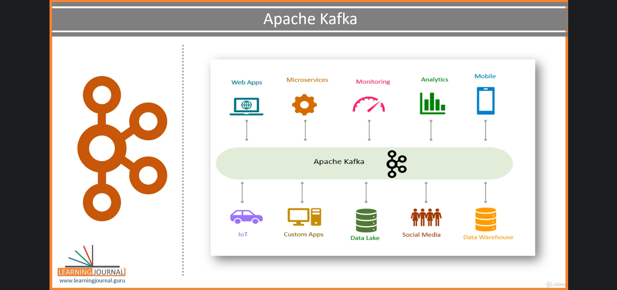

2. Apache Kafka Core Concepts

1. 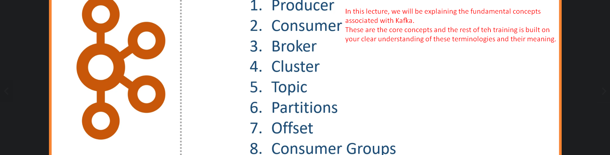
2. Producer is app sending data (msg, msg record) from small to medium sized.
   1. Msg may have any record structure schema but for kafka it is an **array of bytes.**
   2. **Example**:  
      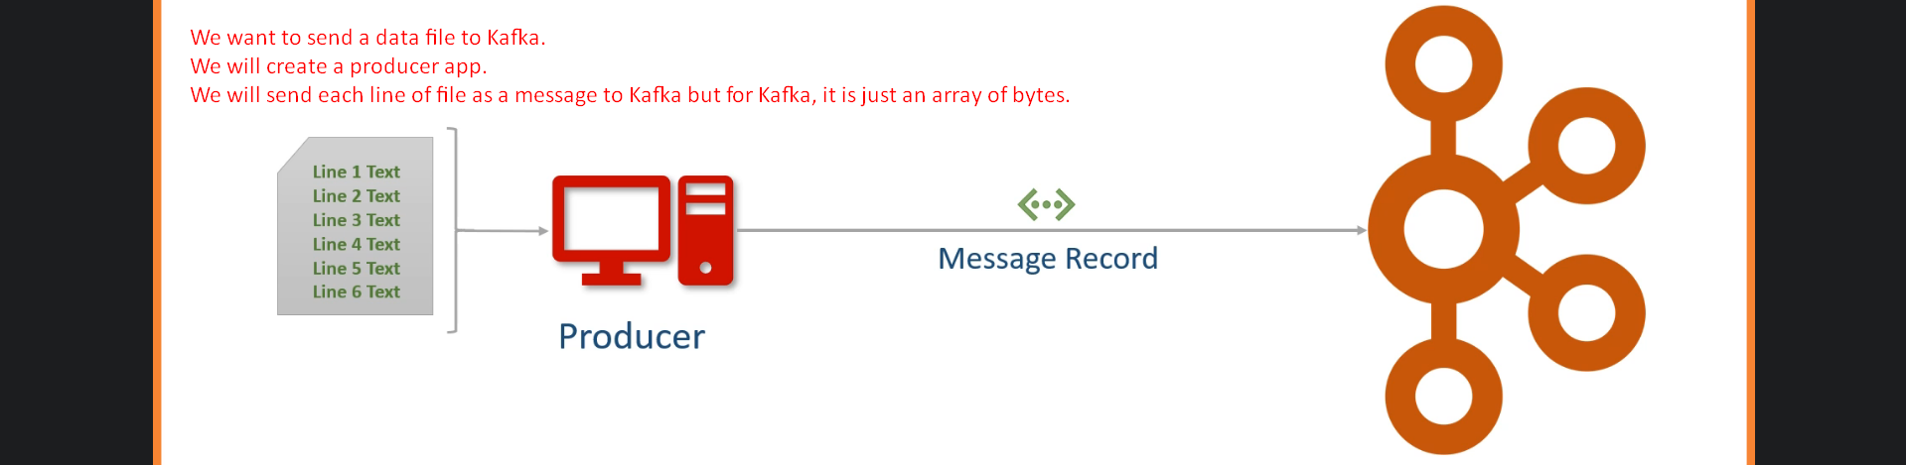  
      Other examples may be like sending a table or result set from a query.   
      So, basically create appropriate Producer App as per your requirement.
3. **Consumer**:
   1. Recipient. Producer doesn’t send directly to consumer but via Broker/Kafka Server. 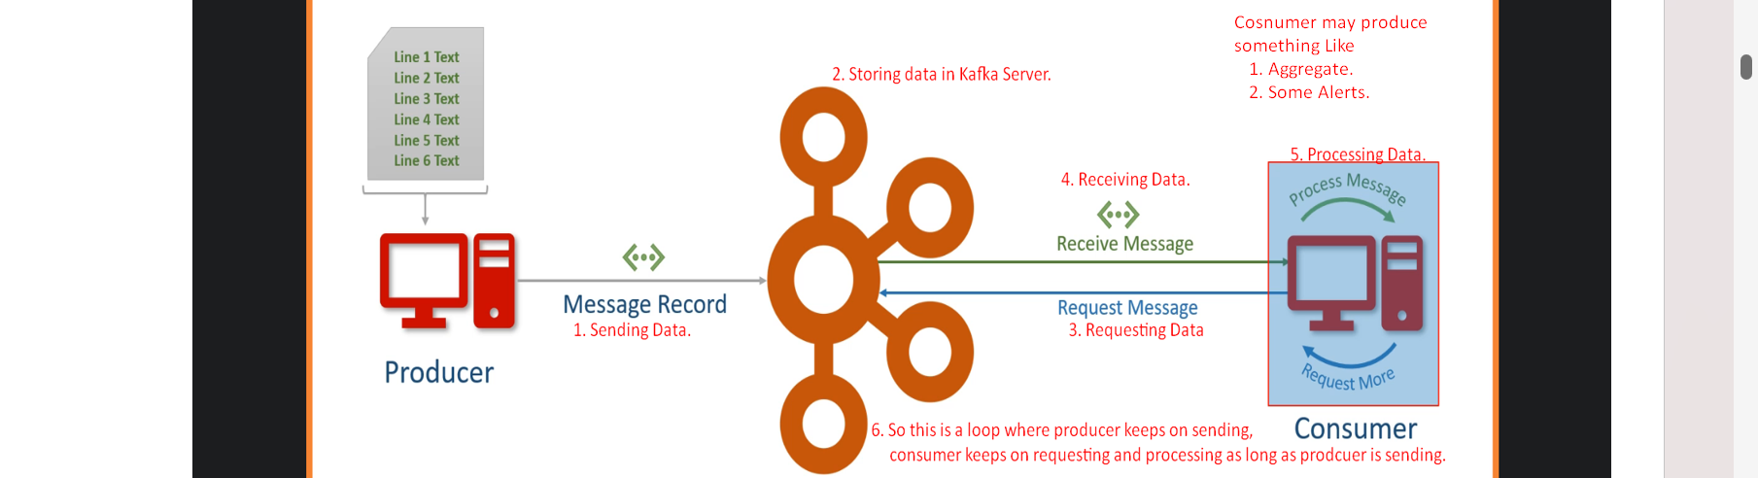
4. **Broker**:
   1. Kafka Server as an agent or a broker to exchange messages.
5. **Cluster**:
   1. Kafka Cluster is a group of computers each running an instance of Kafka Server/Broker for a single purpose.
6. **Kafka Topic**:
   1. **Examples**: Current Load, Consumed Units, Input Fluctuations which one you want.
   2. Arbitrary but unique Name given to a data set. Think like a DB Table Name which is design time decision.
   3. 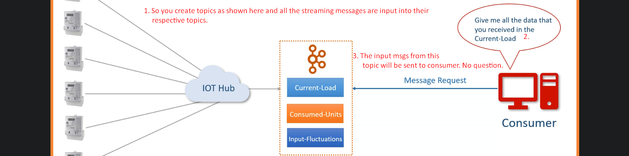
7. **Partitions**: A Smallest and independent portion of a topic
   1. A topic Size may be more than the size of a Kafka Server/Broker.
   2. **Solution**: P1 + P2 + … + Pn = Topic.  
      Where each partition will be assigned to one Kafka Server on a Kafka Cluster. Definitely we need Kafka Cluster.
   3. No of partition is design time decision by an architect.

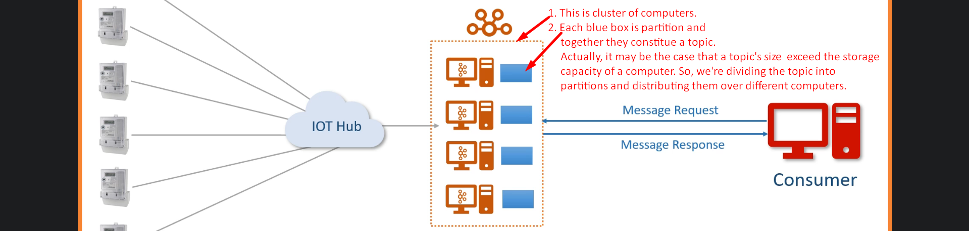

1. **Partition Offset**:
   1. 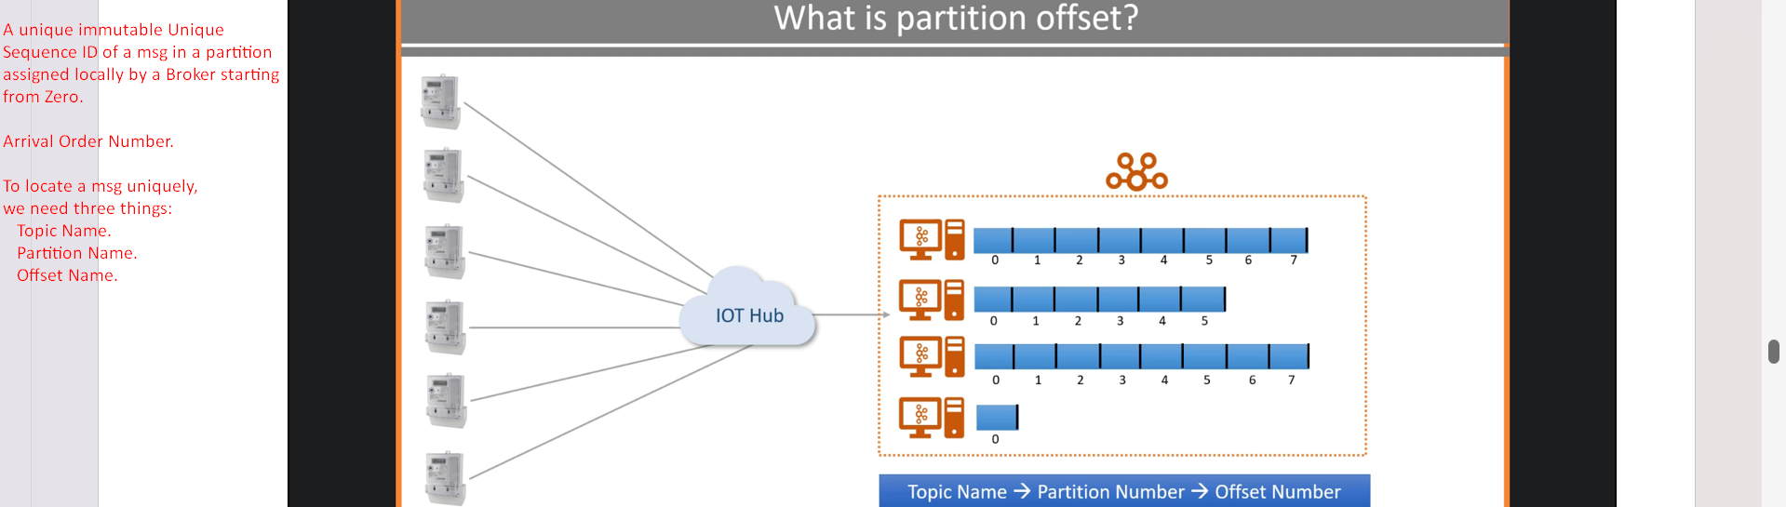
   2. 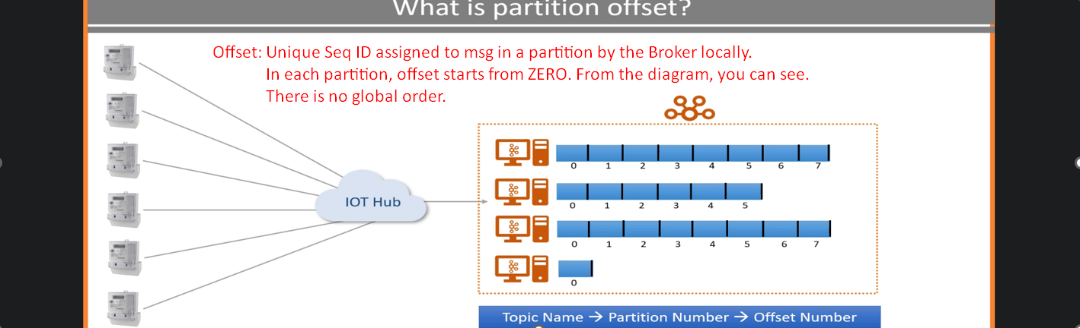
2. **Consumer Group**:
   1. A group of consumers to share a workload. **Purpose** to share workload.
   2. Multiple brokers to share workload when receiving the msgs from a number of producers.
   3. Multiple consumers to consume msgs coming in bulks.  
      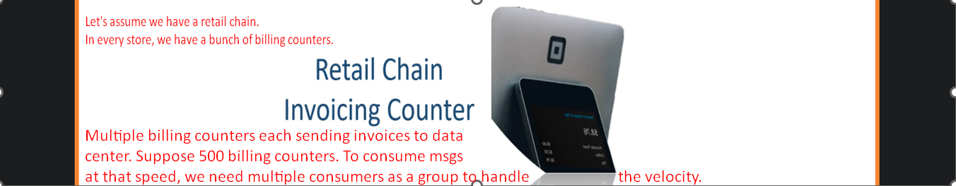  
      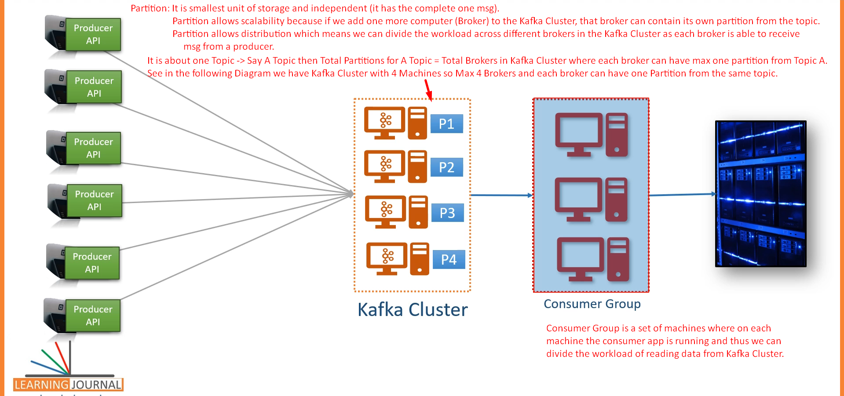  
      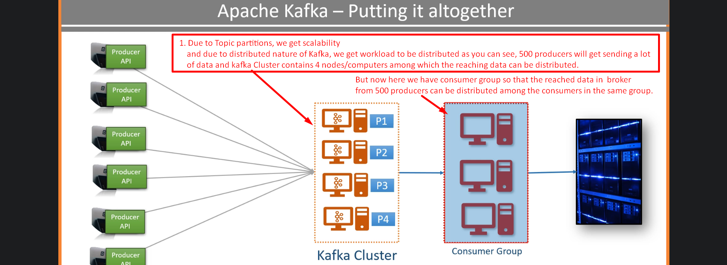

Kafka Connect Core Concepts

Some lectures are skipped. Please complete them.

8. Kafka Quick Start

1. Now we know about 5 components in Kafka  
   
2. **Agenda of this lecture**:  
   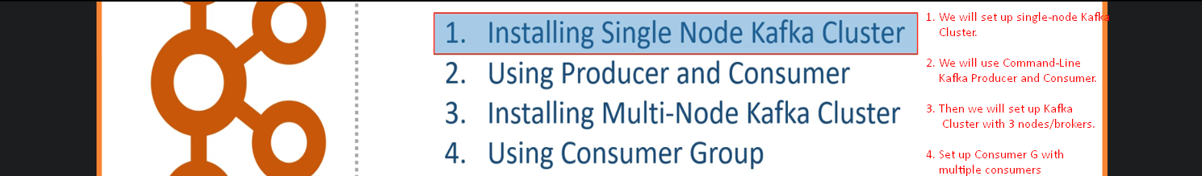
3. Installing Single Node Kafka Cluster
4. **Agenda**: Set up Single Node Kafka Cluster.
5. Skipping some parts. Please read.  
   
6. From above, we will use 2nd option 🡺 Download Apache Kafka Server from Confluent.io.
7. 

As per 2nd option, download Kafka Confluent Community Edition.  
  
  
  
  
  
  


1. How to start Kafka?
2. Starting Kafka is two-Step Process;
   1. **Start 01**: Starting Zookeeper Server.  
      
      1.   
           
         **rem Classpath addition for LSB style path**

**if exist %BASE_DIR%\share\java\kafka\* (**

**call :concat %BASE_DIR%\share\java\kafka\\***

**)**



* 1. **Step 02**: Run Kafka Broker.  
       
     

We created Single-Node Kafka Cluster.

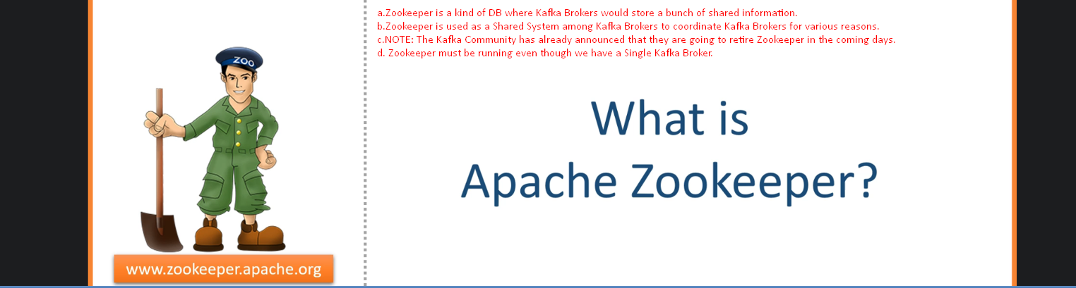

1. Using Command-Line Producer and Consumer
2. 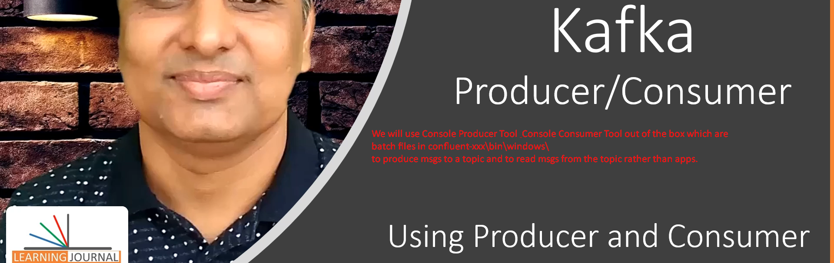
3. 
4. 
5. Sending and consuming Data
6. 1st create a topic using script 🡺   
   2nd Send Data to Kafa Server using script 🡺   
   3rd Consume Data from Kafka Server using script 🡺 



1. When creating topic, need to tell the # of partitions for a topic.  
     
   
2. Command **kafka-topic** options  
   
   1. **--create**: To create a topic
   2. **--partition**: To define partition number.  
      But how to decide the number?  
      
   3. **--replication-factor:** The number of copies for each partition to achieve fault tolerance. Useful only if we have two or more brokers in the cluster.
   4. **--bootstrap-server**: Initial broker network locations from Kafka Cluster for Kafka Clients (Producer & Consumer) to connect initially with Kafka Cluster’s brokers.



1. We will use this script to send data from console to Kafka Cluster.  
   
2. Command to read and send a Data File to Kafka Server.



1. Command to consume msgs from Kafka Server.  
   

11. Installing a Multi-Node Kafka Cluster

1. 
2. 
3. 
4. 
5. Create 2 more copies of the above file as we have total now 3 nodes.  
   
6. Let’s make changes related to properties 🡺 **broker.id**=0, **listeners**=PLAINTEXT://:9092, **log.dirs**=/tmp/kafka-logs-0 🡨 Where partition data is stored.

|  |  |
| --- | --- |
| 1st Broker Configuration |  |
|  | Broker.id=0 |
|  | **listeners**=PLAINTEXT://:9092 |
|  | **log.dirs**=/tmp/kafka-logs-0 |
| 2nd Broker Configuration |  |
|  | Broker.id=1 |
|  | **listeners**=PLAINTEXT://:9093 |
|  | **log.dirs**=../tmp/kafka-logs-1 |
| 3rd Broker Configuration |  |
|  | Broker.id=2 |
|  | **listeners**=PLAINTEXT://:9094 |
|  | **log.dirs**=../tmp/kafka-logs-2 |

1. Let’s start zookeeper but before that let us clean data sent earlier.   
   Go to c:/tmp/ 🡸 Delete everything.   
   Now run zookeeper.   
   zookeeper-server-start.bat <root>/etc/kafka/zookeeper.properties
2. Now run all three brokers  
   kafka-server-start.bat server-0.properties

kafka-server-start.bat server-1.properties

kafka-server-start.bat server-2.properties  
  
For each broker, a kafka-log-x directory will be created.

1. Now run kafka console producer & consumer.  
   kafka-console-producer --topic <name> --broker-list <list>  
   kafka-console-consumer --topic <name> --bootstrap-server <list>

12. Using Consumer Groups

1. 
2. **Agenda**: We already have 3-Node Cluster. Let us do
   1. A topic with 3 partitions.
   2. Two consumers in a consumer group.
   3. Start Producer and Consumer.
3. Create Topic with 3 partitions.  
     
   Starting a consumer .  
   This option **--group < name>** is important when starting multiple consumers in a same group. Starting another consumer in the same group 🡺 **--group <same-name>**  
   **NOTE: Multiple consumers cannot read from same partitions.**  
   Starting Kafka Console Producer and passing CSV file having **1097 records**.  
   **Brief**: We have ZooKeeper up, three Brokers Up, three partitions, Two consumers in the same group.
4. This is what will happen after starting kafka console producer above.  
   Consumer one has been assigned two partitions and consumer 2 has been assigned one partition.  
   
5. 

**NOTE**: Total = 1244 + 663 = 1907



1. Let’s see the Data Directory for each Kafka Broker where partition directory is maintained.
2. 
3. 
4. 
5. 
6. Let’s use the tool **kafka-dump-log.bat**

**Dumping Partition Data from Broker with broker.id=0**

1.   
   You can dump the data itself too. But we’re skipping.
2. Let’s dump the other partitions’ log.  
   **Dumping partition data from broker with broker.id=1**   
     
   **Dumping partition data from broker with broker.id=2**

13. Configuring Your Development IDE

1. double dot means relative path to the location where we are running script.
2. 
3. 
4. 
5. 
6. 
7. 
8. 
9. 
10. 
11. 
12. 

14. Understanding Storage Architecture

1. **Agenda**:
   1. In this section, we’re going to understand Kafka **internals and some architectural concepts**.  
      **NOTE**: These fundamental concepts are critical for the rest of the course.
2. 
3. 3 Primary Responsibilities
   1. Receive msg from Producer and acknowledge.
   2. Store in a log file to safeguard from potential loss and/or to support non-realtime reading.
   3. Deliver when requested by a consumer.
4. 
5. Not completed. Do complete it 😊

15. Kafka Topic and Partitions

1. 
2. 
3. 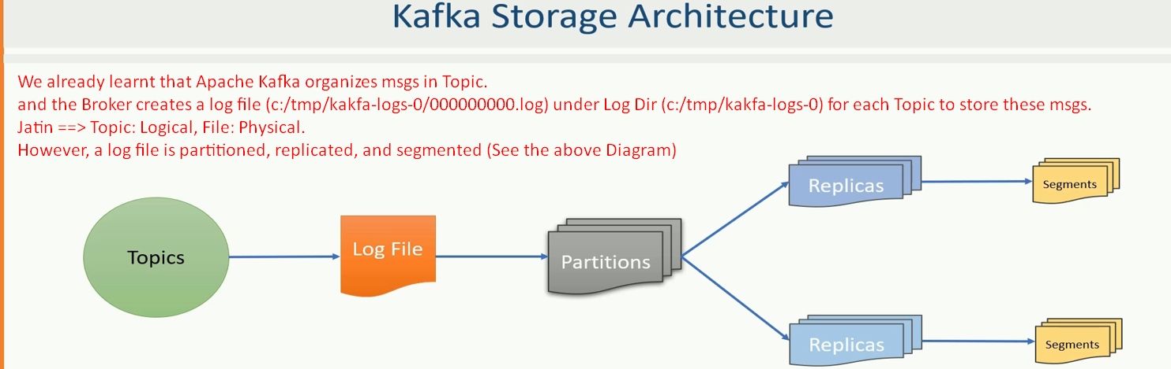
4. 
5. 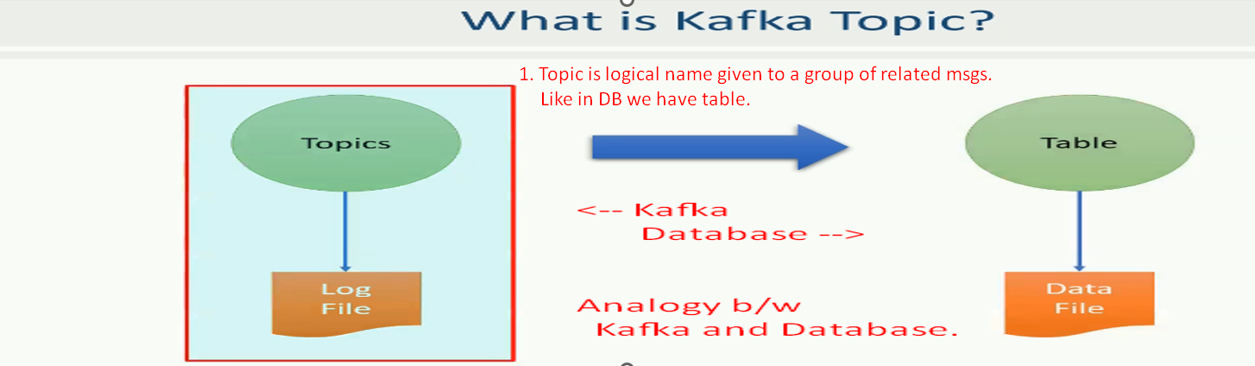
6. 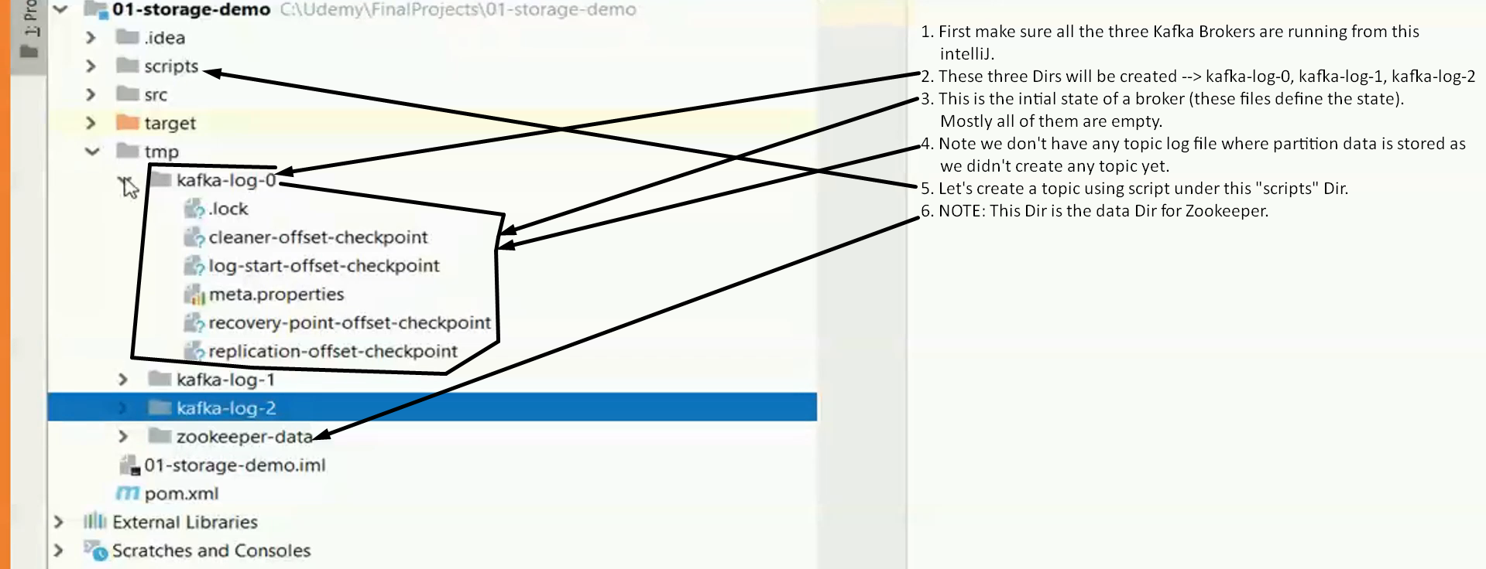
7. 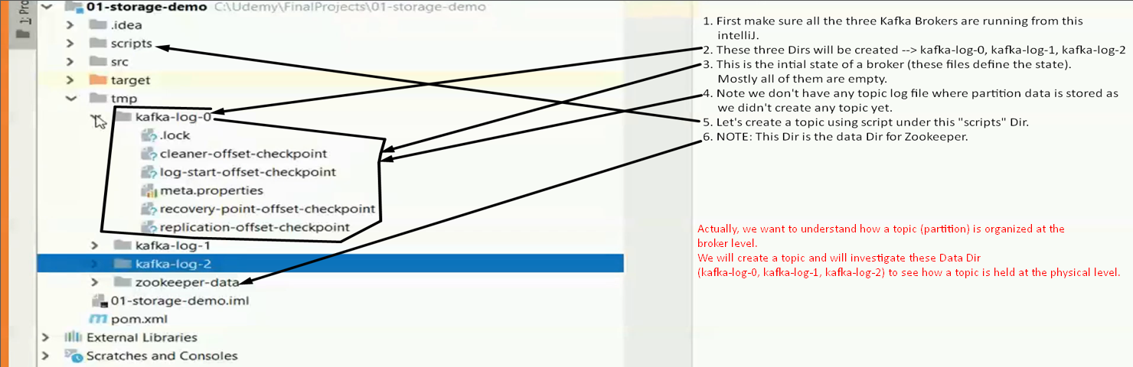
8. 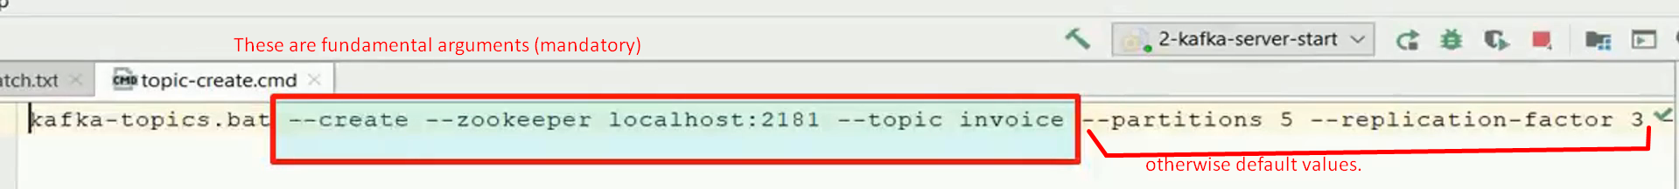  
     
   
9. 
10. Physical file created for each partition for a topic.
11. 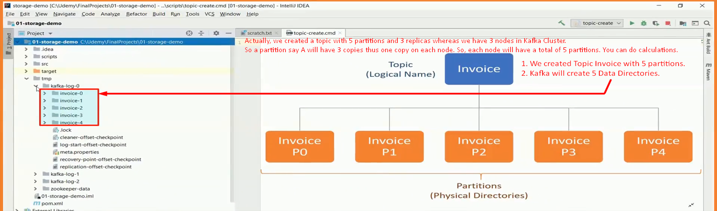

16. Kafka Topic Replication

1. 
2. 
3. 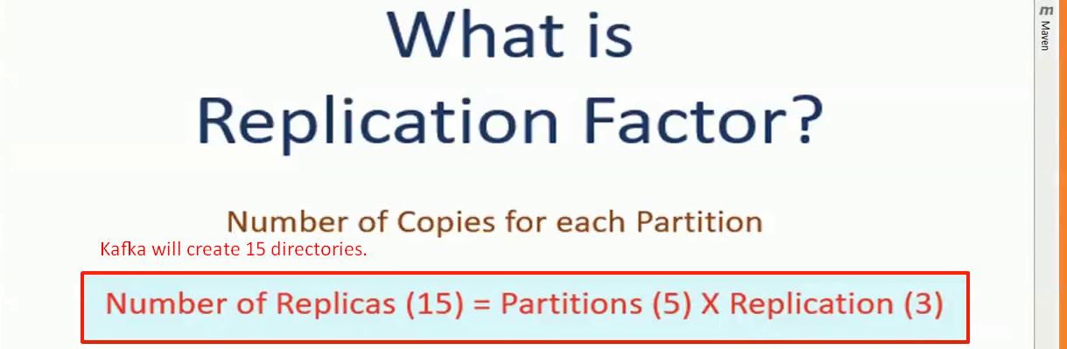
4. 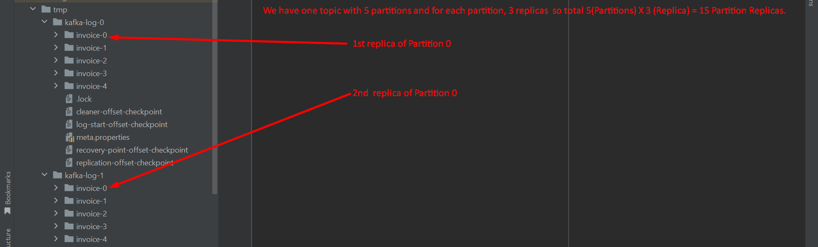

17. Partition Leaders and Followers

1. 
2. 
3. Two categories of partitions
   1. Leader Partitions: No of Leader Partitions based on partition.
   2. Follower Partitions : No of Follower Partitions based on replication-factor number

18. Kafka Log Segments

1. 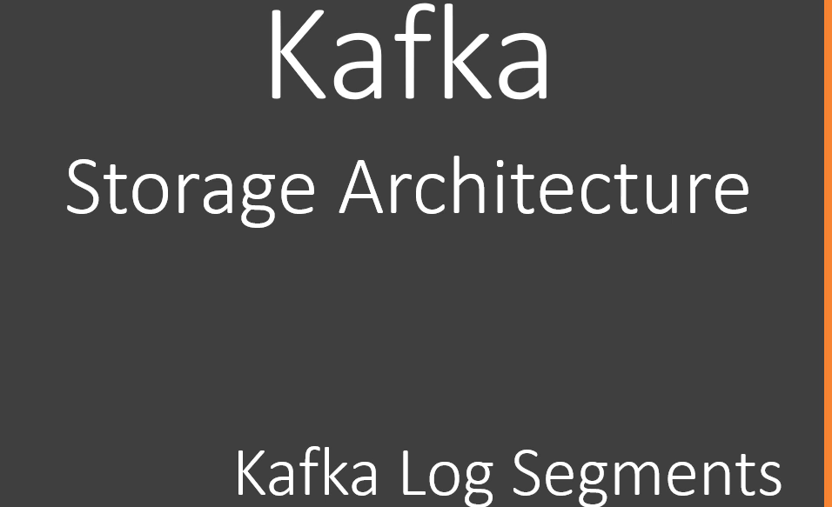
2. 
3. The msgs are stored in log file under partition directory.
4. But instead of storing all the msgs in a single log file, kafka generates several small log files. 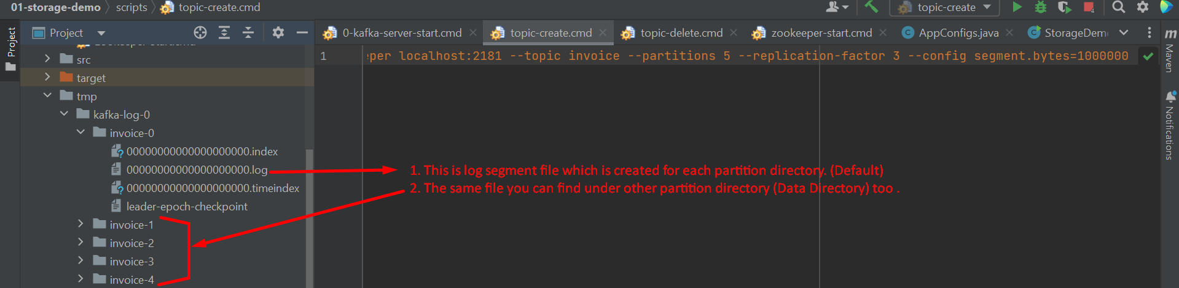
5. 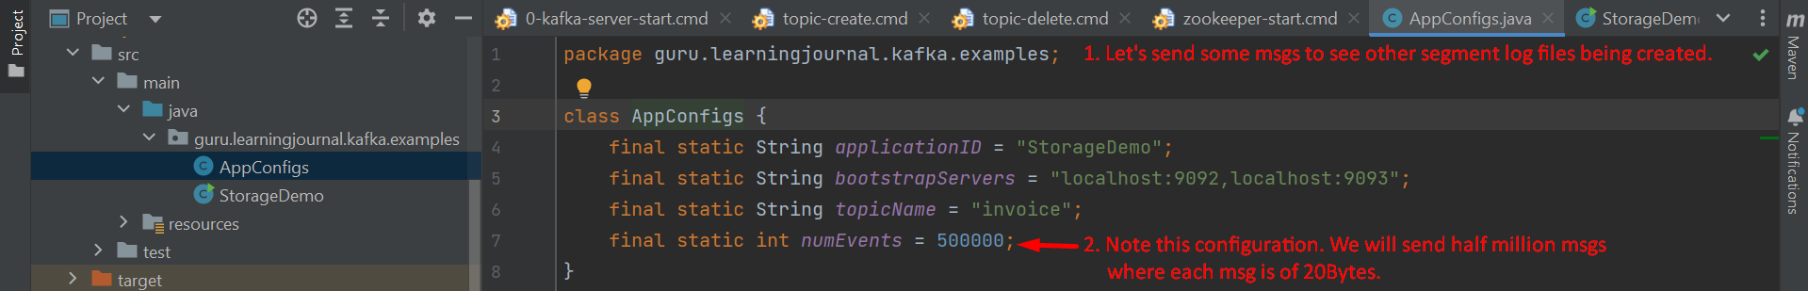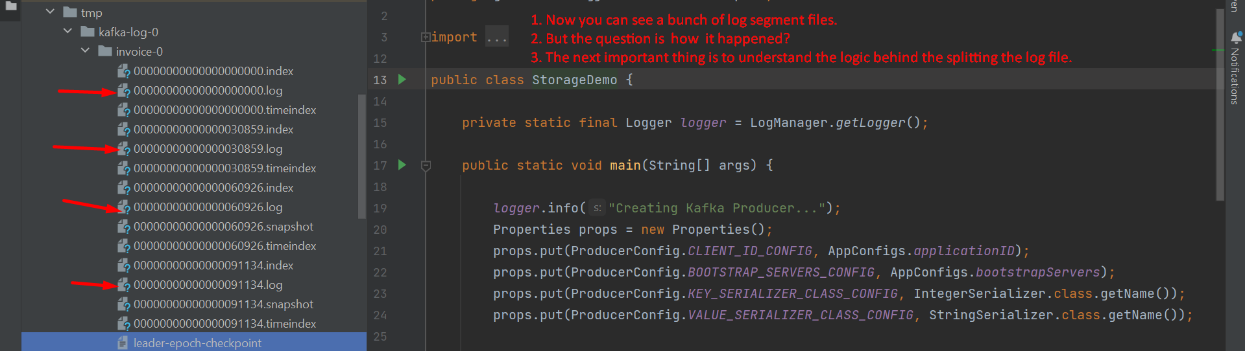
6. 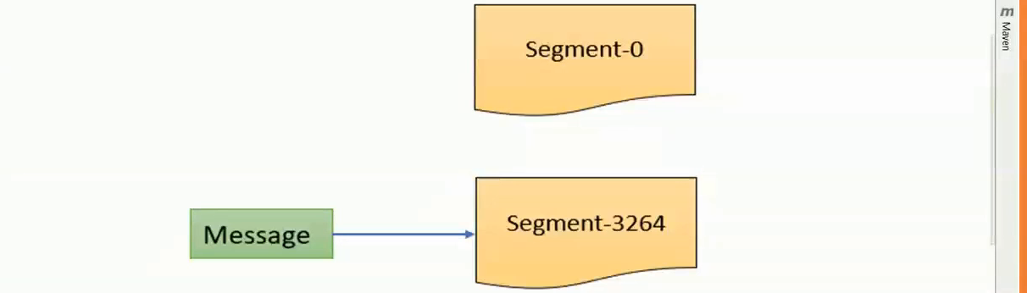
   1. When a partition starts receiving msgs, it stores the msgs into the first segment 00000000000000000000.log.
   2. When the segment limit is reached, it closes the existing segment log file and creates a new segment log file.
   3. **Default limit** is 1 GB or a week of data.   
      Whatever is reached first.
   4. We have set the limit to 1MB.   
      That’s why we can see the segment log files earlier in our case.

19. Kafka Message Offsets

1. 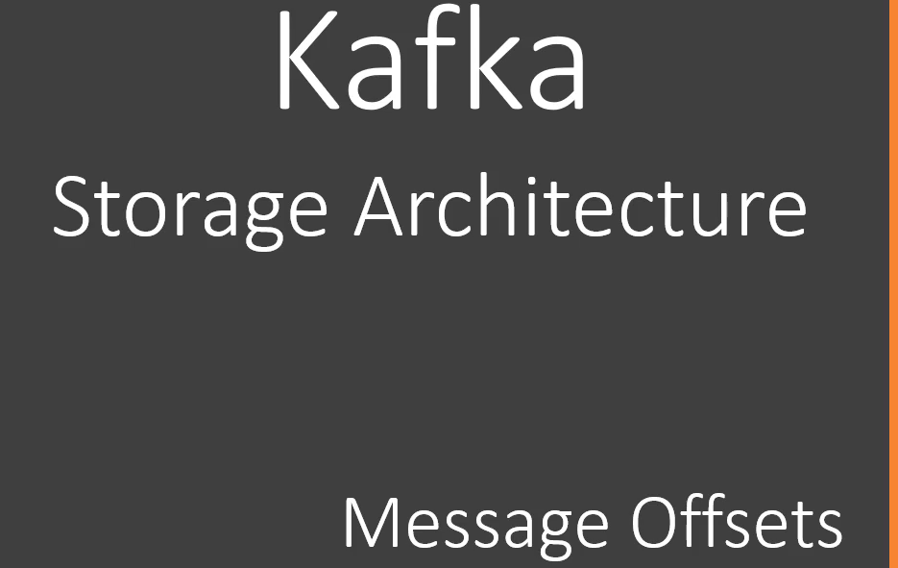
2. 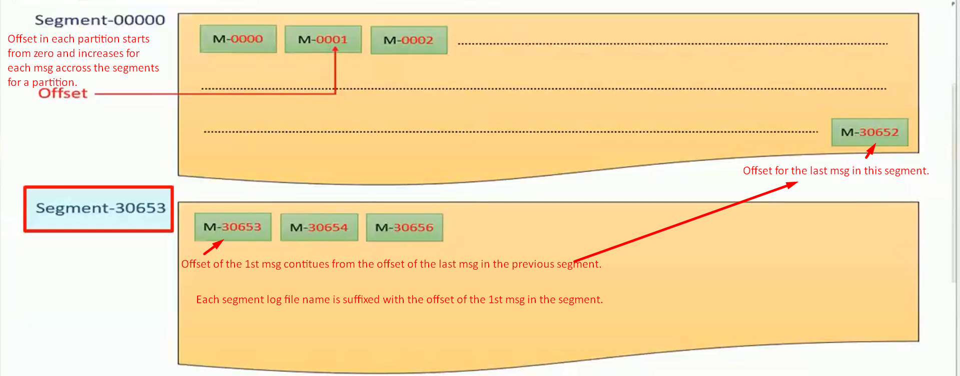 Each Kafka Msg within a single partition is uniquely identified by 64 bit integer offset.  
   Offset numbering continues across the log segments for a partition.  
   The offset of the 1st msg in a new log segment will be the offset of the last msg in the previous log segment + 1.
3. 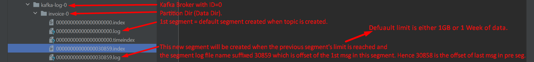
4. 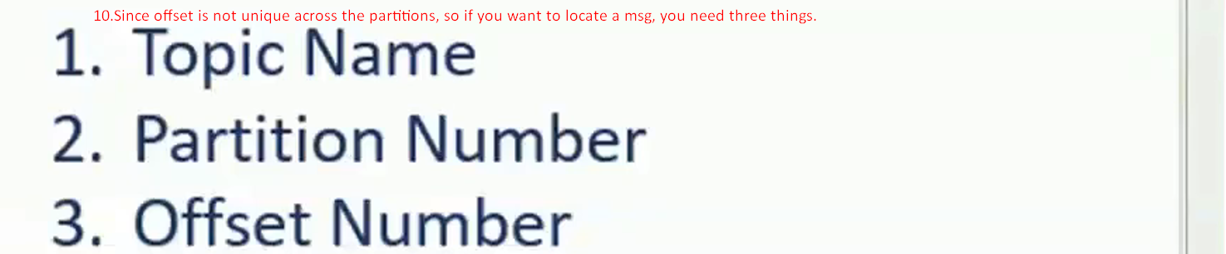

20. Kafka Message Index

1. 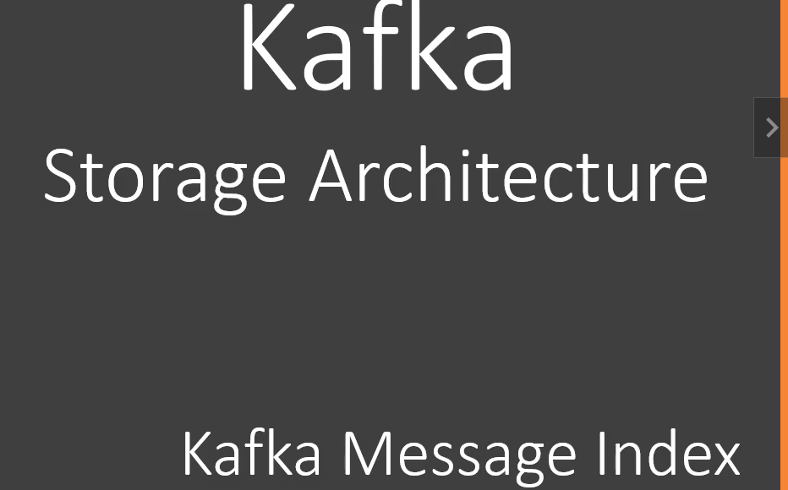
2. As we studied already that Kafka allows consumer app to read msgs based on offset but if we think in terms of DB Query where we seek data based on column name and value, this uniqueness arrangement by kafka like querying msg based on offset (which is an arrival number) seems strange.
3. However, this numbering may not be a problem for stream processing app as they want to process msgs in seq.
4. For example, Loyalty Point calculation app may want to read customer id and amounts for each msg.   
   For this, the app asks for 10 msgs starting with offset 0 it means from 0 to 9 offsets.  
   It will process them and again will ask for next 10 msgs starting from offset 10 to 19.  
   When consumer app demands for msgs with offset, the kafka should be able to send them.   
   For this, Kafka maintains index file along with log segment file.  
   
5.    
   Index file is also put along with Log segment file.
6. 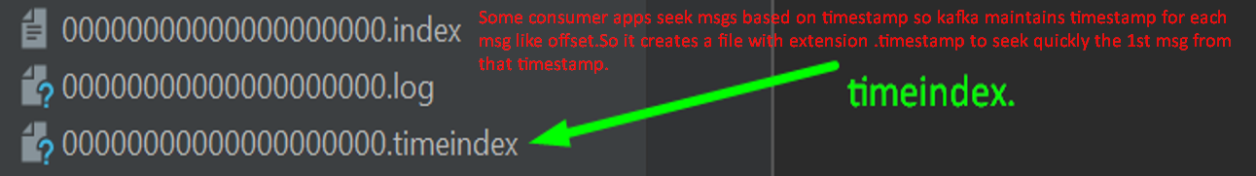

21. Understanding Kafka Cluster

1. 
2. **Cluster**: A group of brokers working together to share workload.
3. **However, the notion of clustering brings out two critical questions**.  
   
   1. **Cluster Membership**: Who manages Cluster membership?
      1. In a typical distributed system, there is a **Master Node** managing list of active brokers. how does it knows
         1. When an existing broker is crashed.
         2. When a new Broker joins the cluster.
   2. **Administrative Tasks**: Who performs the routine administrative tasks in the cluster.
      1. When an existing Broker having some responsibilities crashes, to whom those responsibilities are to be assigned.
4. 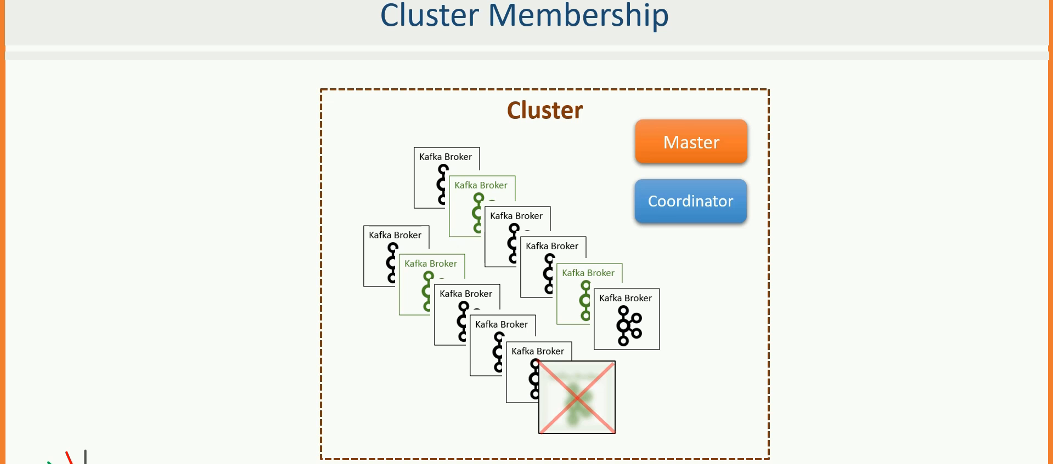

22. Zookeeper in Kafka